Ego network exercise – UCINET + netdraw screen
Below how does the data looks in UCINET
Matrix of relations – who knows whom
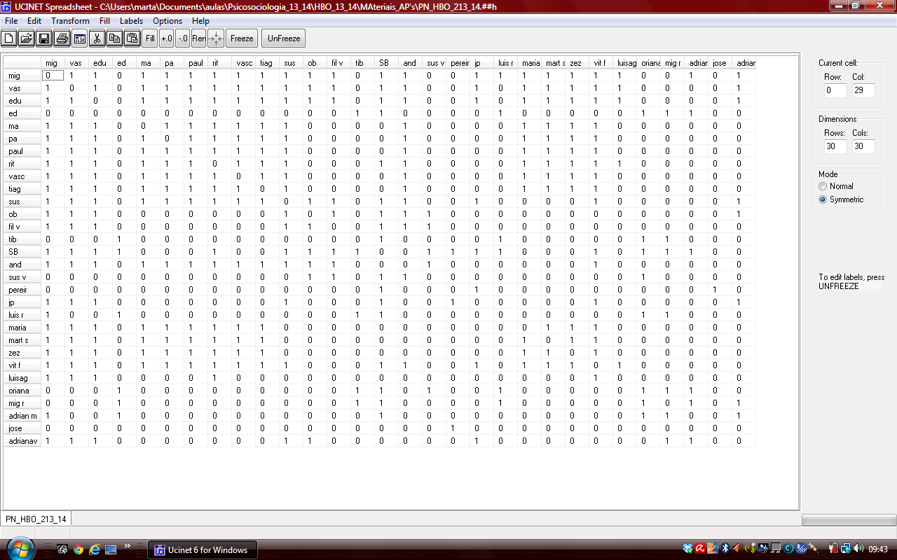

Vectors with attributes : relation, place of living, social support

Netdraw instructions
Open netdraw; click the Little folder on the left (below edit) _ you will visualise the map of the matrix as shown below
-

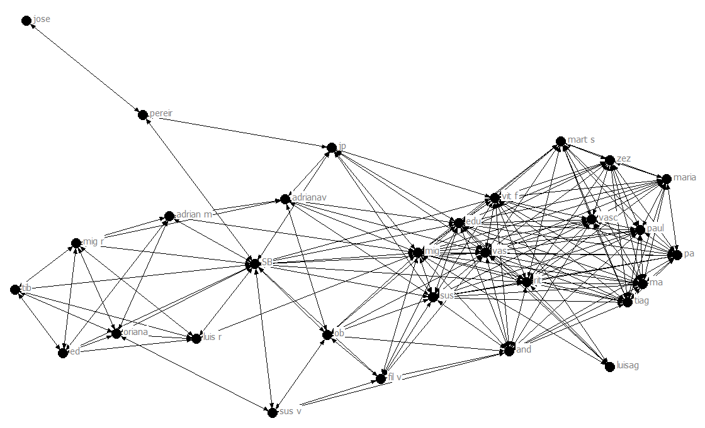

Next open the second matrix – which has 5 columns : the labels (names of people) the relation (family, etc) the place of living (lisbon, etc), the category of age and the social support dimensions .
Click the little folder with an A (located between edit and layout in the image above)

Then you click the Icon which has Little squares with different colours:
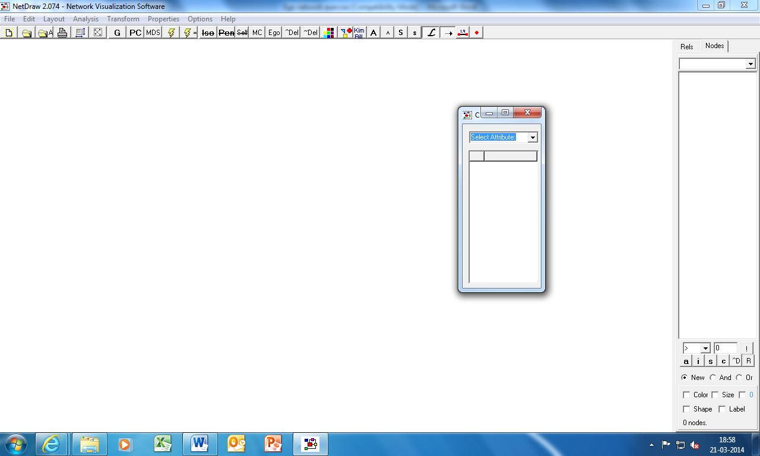

It will ask you to select attribute , and you select “relation”. The result will be that the round points (nodes) of the graph will change colours according to the relation of that person.
Next you select the icon with little shapes in it , of different colours. You select attribute “place of living” (or “age”) (do both in separate drawings). It will change the coloured nodes into different shapes according to the place of living of the person.
The graph will now allow to visualise your personal network differentiating the places of living (or age) + the type relationship
Next you go to properties Nodes symbols size attribute base and select your social support attribute. The size of symbols (nodes) will change size according to whether the person gives you 0 -5 social support.
You save the graph in JPEG format for instance
File save diagram as Jpeg
Colour Print it and hand it in

